Week 2 - Recycling and Green Tips - Creative Recycling MAVO/HAVO/VWO
Last week we had a look at some of the reasons to recycle, recycling plastic bottles, tips to live a greener life and what we can do to make the earth happier. Today we are going to have a look at some other ways of recycling plastics.
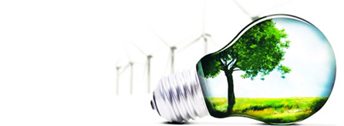

Part 1: Plastic recycling 101 MAVO/HAVO/VWO
ReCommunity is a company that organises recycling and makes sure we take care of our future. Therefore, their slogan is ‘don’t throw away our future’. This first section of the lesson you are going to learn more about recycling and the processes involved.
A. First watch the video below about ReCommunity material recovery centre and answer the questions in English.
https://vimeo.com/79250392
- What happens at the scale?
- What is stored at the tipping store?
- What is a conveyor?
- What do the sorters pick out of the pile, why do they pick these items out?
- What does “ONP” stand for, what does it sort?
- Why does the paper sorting get extra attention?
- What does the tour guide get asked several times a day?
- What do regular people call PET?
- How is aluminium taken out of the trash?
- What word is used to describe the large blocks of recycling?
- How do they take paper and other items out of the glass?
- What happens to the items that are not recycled?
- Where does the material go to after the sorting? (3 places)
- How long does it take for the recycling to go back to stores?

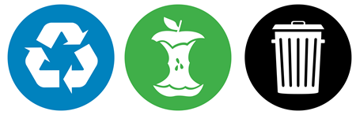

Part 2: “I want to be a bench” – Keep America Beautiful MAVO/HAVO/VWO
‘I want to be a bench’ is a project by the Keep America Beautiful foundation. The organisation tries to make people’s lives more beautiful and greener. One way of doing that is by promoting recycling, they do this in a pretty creative way.
B. Have a look the video below to learn more about this project – and answer the questions below.
https://www.youtube.com/watch?v=2zRfMwzhUpU
- Why is it important to understand the visual recycling process?
- Why did they start the ‘I want to be a bench project’?
- How did they make the benches?
- What does recycling do to people?

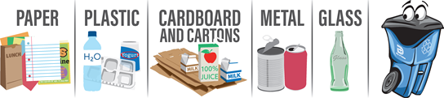

Part 3: Creative recycling MAVO/HAVO/VWO
Not only larger projects turn the plastics separated by companies such as ReCommunity into items that make us feel happy. Here are a few people who turn plastics and other rubbish into beautiful items that make them and others happy.
http://www.bbc.com/news/magazine-34006625
- The painter lives in Britain. True/False
- He is working on a painting of the king. True/False
- Nobody else (known) is working like this. True/False
- The painter has to buy his plastics from a tip. True/False
- It is very inexpensive to make this type of art. True/False
HAVO/VWO
C. Why is art important to the first artist and to the people around him?
http://www.bbc.com/news/magazine-28754446
- What does the artist do during the day?
- Why does would he like a world out of tyres?
- Name 3 things he makes with the tyres.
- How did people feel about his methods at first?
- How does he get the tyres?
- What does he say about the sea? How does he feel about it?
D. Hubcap fish VWO
The final video is a news item about a British man who uses another item we see each day; Hubcaps (wieldoppen) to create and sell his artwork. Watch his video and answer the following questions.
http://www.bbc.com/news/magazine-27803679
- What does he do when he really likes one of the items he has made?
- How does the artist feel about throwing away hubcaps and other items?
- How did he start collecting hubcaps?
- What does he think is beautiful and valuable about them?
- What item did he originally plan to make?
- Why does the wire need to be galvanised?
- Where did he go to inspire his art concept?
Part 4: Recycling game MAVO/HAVO/VWO
Finished with all the previous activities?
Play this online interactive recycle game! https://berecycled.org/game/

